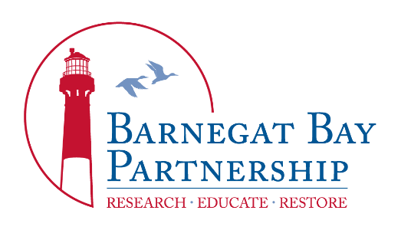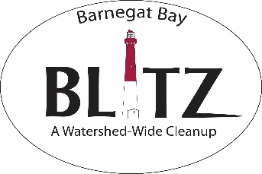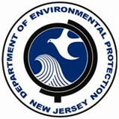
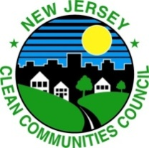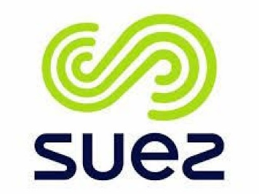

Starter Packet
2020 Barnegat Bay Blitz “Rain Barrel Challenge”

Overview: In 2011, the New Jersey Department of Environmental Protection (NJDEP), in partnership with the New Jersey Clean Communities Council and SUEZ Water, established the Barnegat Bay Blitz Rain Barrel Challenge. With their assistance, the Barnegat Bay Partnership (BBP), the National Estuary Program for the Barnegat Bay, is taking the lead for organizing the Blitz and Rain Barrel Challenge in 2020. The Blitz is an annual clean-up of the Barnegat Bay watershed, and the Rain Barrel Challenge is an annual art competition with an environmental theme for schools and youth organizations. The Rain Barrel Challenge aims to educate young people about the bay and its 660-square mile watershed and engage them in stewardship actions.
Contact: For more information regarding the 2020 Rain Barrel Challenge, contact Karen Walzer, BBP’s Public Outreach Coordinator, at kwalzer@ocean.edu or 732-255-0472 x 2.
2020 Rain Barrel Design Theme: “Earth Day – Celebrating 50 Years of Protecting Our Planet!”
On the first Earth Day on April 22, 1970, people came together to support protection of the environment, and the NJDEP was established on the same date.
Help us celebrate the 50th anniversary of Earth Day by depicting on your 2020 barrel the importance of protecting the special habitats of the Barnegat Bay. Ideas may include but are not limited to:
1) Wetlands – Nature’s Sponge and Filter: Salt marshes along the bay act like a sponge, soaking up water from high tides and storms, and as filters removing pollution from the water. Supporting an amazing variety of wildlife, wetlands are home to shore birds, crabs, shellfish, mammals, insects, and plants.
2) Seagrass Beds – Nursery for Marine Life: Seagrass beds in the bay provide food and habitat for fishes, crabs, and other marine life. They are also important nursery areas for juvenile fishes and invertebrates, providing both food and shelter from predators.
Eligible Participants: Those eligible to participate include schools and youth organizations (such as scouting groups or church youth groups) located in the Barnegat Bay watershed. The watershed incorporates all 33 municipalities in Ocean County and portions of four in southern Monmouth County (Millstone, Freehold, Howell, and Wall Townships). To learn about the geographic boundaries of the watershed, visit www.barnegatbaypartnership.org/learn/watershed-map/.
Number of Barrels: Due to a limited barrel supply, each school/organization is limited to one barrel. PLEASE NOTE: ALL BARRELS MUST BE SANDED AND PRIMED BY PARTICIPANTS! The BBP will send instructions about how to prepare the barrels for painting to all registered participants.
Competition: All schools and organizations participating for the first time will be required to have a presentation before receiving a barrel. Presentations are optional for returning schools and organizations. Entry into the Rain Barrel Challenge competition is limited to one barrel per school/organization. If more than one barrel is painted, it will be up to the school/organization to determine which of the barrels will be entered in the competition. Each entry must include:
1) the completed Entry Form, including a descriptive paragraph telling the judges how the barrel fits the theme, how the class (or youth group) came up with the design, and how students (or group members) created the barrel’s artwork, and 2) a photo(s) of the rain barrel being entered into the competition. By submitting an entry, you will be granting the BBP permission to use the photo(s) of your barrel for educational or other purposes. Email the Entry Form and photo(s) to Karen Walzer at kwalzer@ocean.edu by the deadline for entries.

Clear-Coating of Barrels: Clear-coating is recommended for barrels that will be installed or displayed outdoors. The Barnegat Bay Partnership is arranging for clear-coating of the competition barrels by the Ocean County Vocational Technical School. Contact Karen Walzer at kwalzer@ocean.edu to schedule a date to drop off your competition barrel for clear-coating.

Voting: A panel of judges comprised of Rain Barrel Challenge partner organizations and/or members of the BBP’s Communication and Education Committee will vote to select the winning barrel. The panel of judges will evaluate each rain barrel based on the following criteria:
- How well the theme is portrayed
- Originality and creativity of design
The decision of the judges will be final.

Rain Barrel Challenge Winners: The winning school/organization will have the opportunity to host a Barnegat Bay Festival Day, which feature hands-on educational demonstrations and activities about the Barnegat Bay Watershed. The BBP and partners will organize and present the festival to the winning class/grade/school/group; festival details will depend on the size of the school/group. Additionally, the winning barrel will be clear-coated and displayed all summer at SUEZ Water in Toms River, New Jersey.

Competition Timeline:
- January 8, 2020: The attached Registration Form is due to the Barnegat Bay Partnership no later than this date. You will receive a confirmation email by January 10, 2020.
- January 13 – February 28, 2020: Time frame for presentations by the AmeriCorps Watershed Ambassador or Barnegat Bay Partnership speakers and delivery of rain barrels to registered schools or groups. The presentation will cover water flow and water pollution and provide details about the competition; it may be a classroom presentation or auditorium presentation, depending on participant needs. Presentations may be scheduled earlier for early registrations.
- April 20, 2020: Deadline for submitting the attached Entry Form and a photo(s) of the completed (and competing) rain barrel to kwalzer@ocean.edu. On the Entry Form, you must provide a descriptive paragraph telling the judges how the barrel fits the theme, how the class (or youth group) came up with the design, and how students (or members) created the barrel’s artwork.
- May 1, 2020: Judges will complete voting and select a winner by this date.
- May 6, 2020: The final winner will be contacted by this date to arrange for the Barnegat Bay Festival Day at their school/location.
- June – October, 2020: The winning barrel will be showcased at Suez Water in Toms River.

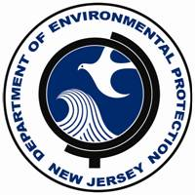
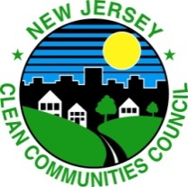

Barnegat Bay Blitz Rain Barrel Challenge
Registration Form
Due: January 8, 2020

School/Organization Information

School/Organization Name______________________________________________________
Grade Level Participating ________________________________________________________
School/Organization Address
Street ____________________________________________________________
Town _____________________________________________________________
County ____________________________________________________________
Zip _______________________________________________________________
Contact Name_____________________________________________________________
Phone # ___________________________________________________________
Email _____________________________________________________________

Total Number of Students in School (or Members in Youth Group) ______________________

NOTE: You will receive a confirmation email by January 10, 2020. If you do not receive a confirmation, please email Karen Walzer at kwalzer@ocean.edu.

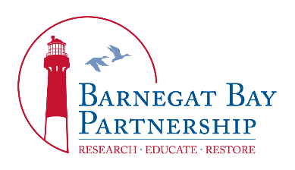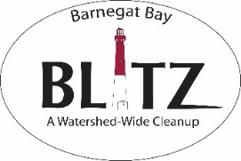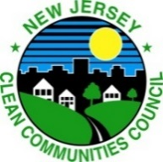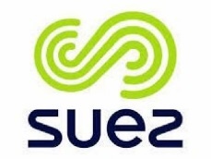

Barnegat Bay Blitz Rain Barrel Challenge
Entry Form
PLEASE complete and email to kwalzer@ocean.edu with a photo(s) of the
school/organization’s rain barrel.
DUE: April 20, 2020
School/Organization information
School/Organization Name_________________________________________________________
School/Organization Address_______________________________________________________
Contact Name___________________________________________________________________
Contact’s Phone # ________________________________________________________________ Email__________________________________________________________________________
Grade Level Participating ___________________________________________________________
Total number of Students in School (or Members in Youth Group) __________________________
Description of Barrel_______________________________________________________________
Your descriptive paragraph telling the judges how the barrel fits the theme, how the class (or group) came up with the design, and how students (or members) created the barrel’s artwork. ________________________________________________________________________________________________________________________________________________________________________________________________________________________________________________________________________________________________________________________________________________________________________________________________________________________________________________________________________________________________________________________________________________________________________________________________________________________________________________________________________________________

